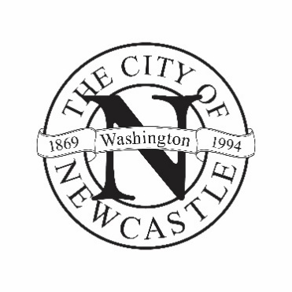
CITY OF NEWCASTLE

APPLICATION FOR CITY COUNCIL

Deadline for Applying: 5 p.m., August 20, 2021
Most Likely Date for Public Interviews: 7-10 p.m., September 21, 2021

If you are interested in participating in local government by becoming a City Councilmember, please complete this application and return it with a resume and letter of interest by mail or email to:

City of Newcastle
Attn: City Clerk
12835 Newcastle Way, Suite 200
Newcastle, WA 98056-1316
cityclerk@newcastlewa.gov
Applicants must be registered voters and must have resided within the City of Newcastle for one year prior to their appointment.

Please note that this application and related materials are public records subject to disclosure under state law (Ch. 42.56 RCW). Expect all the following information to be provided to the public.

The City Council meets regularly on the 1st and 3rd Tuesdays of each month at 7:00 p.m. and as otherwise necessary in the Council Chambers at City Hall.

Name: ________________________________________________________________________
Last First MI

Residential Street Address: ____________________________, Newcastle, WA Zip: _________

Preferred Phone Contact: ______________________________ (mobile – work – home – other)

Preferred Email Contact: ___________________________________ (personal – work – other)

Occupation: ___________________________ Employer: _______________________________

Are you able to attend evening meetings? Yes No

Are you able to attend occasional daytime meetings? Yes No

Why are you interested in serving on the City Council?
______________________________________________________________________________
______________________________________________________________________________
______________________________________________________________________________

Work Background:
______________________________________________________________________________
______________________________________________________________________________
______________________________________________________________________________

Past or present community activities and role (organizations, service groups, etc.)
______________________________________________________________________________
______________________________________________________________________________
______________________________________________________________________________

Specific knowledge or skills you feel would benefit the City Council:
______________________________________________________________________________
______________________________________________________________________________
______________________________________________________________________________

Other comments/additional information for consideration:
______________________________________________________________________________
______________________________________________________________________________
______________________________________________________________________________

Signature: _____________________________________ Date:___________________

